**Task A2: Übersicht**

1. DB mit Testdaten bestücken.

File db\seeds.rb

# encoding: utf-8

Product.delete_all

Product.create(title: 'CoffeeScript',

description:

%{<p>

CoffeeScript is JavaScript done right. It provides all of JavaScript's

functionality wrapped in a cleaner, more succinct syntax. In the first

book on this exciting new language, CoffeeScript guru Trevor Burnham

shows you how to hold onto all the power and flexibility of JavaScript

while writing clearer, cleaner, and safer code.

</p>},

image_url: 'cs.jpg',

price: 36.00)

# . . .

Product.create(title: 'Programming Ruby 1.9',

description:

%{<p>

Ruby is the fastest growing and most exciting dynamic language

out there. If you need to get working programs delivered fast,

you should add Ruby to your toolbox.

</p>},

image_url: 'ruby.jpg',

price: 49.95)

# . . .

Product.create(title: 'Rails Test Prescriptions',

description:

%{<p>

<em>Rails Test Prescriptions</em> is a comprehensive guide to testing

Rails applications, covering Test-Driven Development from both a

theoretical perspective (why to test) and from a practical perspective

(how to test effectively). It covers the core Rails testing tools and

procedures for Rails 2 and Rails 3, and introduces popular add-ons,

including Cucumber, Shoulda, Machinist, Mocha, and Rcov.

</p>},

image_url: 'rtp.jpg',

price: 34.95)

1. Images zu Testdaten bereitstellen:

Alle Dateien von C:\dev\depot_vorlage\A2\app\assets\images\ in **Projekt** **(depot) Ordner \app\assets\images** kopieren.

1. Testdaten laden:  
   rake db:seed
2. Stylesheet \app\assets\stylesheets\products.css.scss anpassen :

// Place all the styles related to the Products controller here.

// They will automatically be included in application.css.

// You can use Sass (SCSS) here:

.products {

table {

border-collapse: collapse;

}

table tr td {

padding: 5px;

vertical-align: top;

}

.list_image {

width: 60px;

height: 70px;

}

.list_description {

width: 60%;

dl {

margin: 0;

}

dt {

color: #244;

font-weight: bold;

font-size: larger;

}

dd {

margin: 0;

}

}

.list_actions {

font-size: x-small;

text-align: right;

padding-left: 1em;

}

.list_line_even {

background: #e0f8f8;

}

.list_line_odd {

background: #f8b0f8;

}

}

1. Stylesheet Applikation zuordnen:

In \app\views\layouts\application.html.erb folgende Änderung (an der Stelle des Pfeils) vornehmen:

<body class='<%= controller.controller_name %>'>

an der Stelle des Pfeils vornehmen oder  
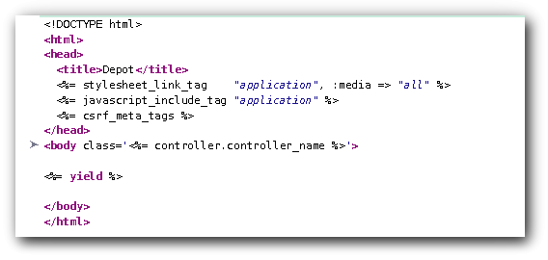

1. Template für Liste Anpassen

Folgende Codes in \app\views\products\index.html.erb integrieren.

#encoding: UTF-8

<h1>Produktliste</h1>

<table>

<% @products.each do |product| %>

<tr class="<%= cycle('list_line_odd', 'list_line_even') %>">

<td>

<%= image_tag(product.image_url, class: 'list_image') %>

</td>

<td class="list_description">

<dl>

<dt><%= product.title %></dt>

<dd><%= truncate(strip_tags(product.description),

length: 80) %></dd>

</dl>

</td>

<td class="list_actions">

<%= link_to 'Anzeigen', product %><br/>

<%= link_to 'Bearbeiten', edit_product_path(product) %><br/>

<%= link_to 'Löschen', product,

confirm: 'Sind Sie sicher?',

method: :delete %>

</td>

</tr>

<% end %>

</table>

<br />

<%= link_to 'Neues Produkt', new_product_path %>